**ANDAMAN** **ISLANDS**:

Reaching the Andaman Islands from Vijayawada involves a combination of air and sea travel. Here's a detailed overview of the transportation options:

### 1. By Air and Sea:

#### Route:

1. **Vijayawada to Port Blair by Air**: Fly from Vijayawada Airport (VGA) to Veer Savarkar International Airport (IXZ) in Port Blair, the capital city of the Andaman Islands.

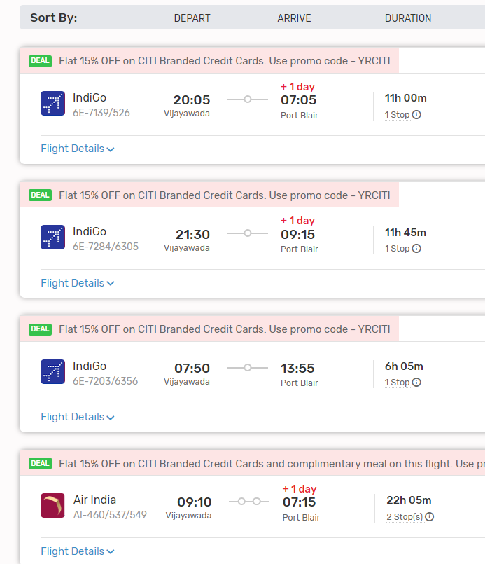

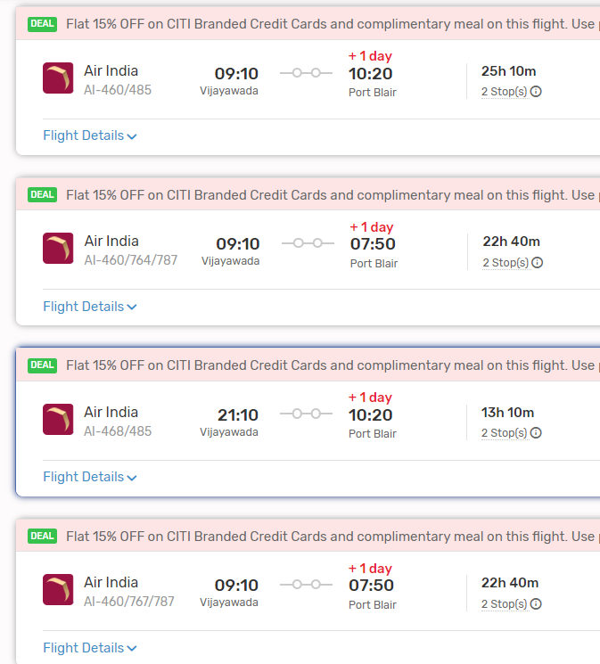

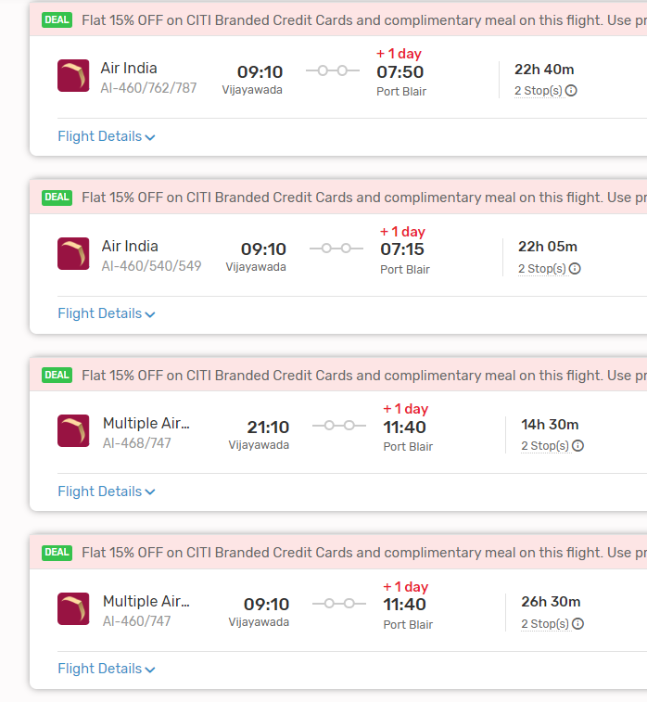

2. **Port Blair to Other Islands by Sea**: From Port Blair, you can travel to other islands in the Andaman archipelago, such as Havelock Island, Neil Island, and others, by ferry or boat.

#### From Port Blair to Other Islands:

- Multiple ferry services operate between Port Blair and other islands in the Andaman group. The journey durations vary depending on the destination island, ranging from around 1 to 3 hours.

#### Ferry Services:

- Government-operated and private ferry services are available for inter-island transportation. The types of ferries include government ferries, private ferries, and luxury catamarans. Advance booking is recommended, especially during peak tourist seasons.

#### Considerations:

- Weather conditions, especially during the monsoon season (roughly May to September), can affect ferry services. It's essential to check the weather forecast and ferry schedules before planning your trip.

### 2. By Air Only:

#### Route:

- Alternatively, you can fly directly from Vijayawada to Port Blair without traveling by sea to other islands. This option is suitable for travelers who prefer to explore only the main island of Andaman.

#### Flight Duration:

- The direct flight from Vijayawada to Port Blair typically takes around 2.5 to 3.5 hours, depending on the airline and any layovers.

#### Airlines:

- Several airlines operate flights between major Indian cities, including Vijayawada and Port Blair. It's advisable to check the flight schedules and book tickets in advance to secure the best deals.As mentioned in the above images.

#### Conclusion:

- Traveling to the Andaman Islands from Vijayawada involves flying to Port Blair, followed by sea travel to other islands if desired. Both air and sea routes offer unique experiences and stunning views of the Andaman Sea. Before planning your trip, consider factors such as travel time, budget, and preferred mode of transportation. Additionally, ensure to check travel advisories and COVID-19-related guidelines before making any bookings.